Project Design Phase
Solution Architecture

Date | 26 -052025
Team ID | LTVIP2025TMID58811
Project Name | Doc Spot
Maximum Marks | 4 Marks

Solution Architecture:
To provide a user-friendly, secure, and scalable healthcare appointment booking system that bridges the gap between patients and healthcare providers.
- Effortless Appointment Booking
- End-to-End Patient Management
- Scalable user authentication and authorization
- Secure and trackable payment transactions
- Reliable real-time chat and notifications

Example - Solution Architecture Diagram:

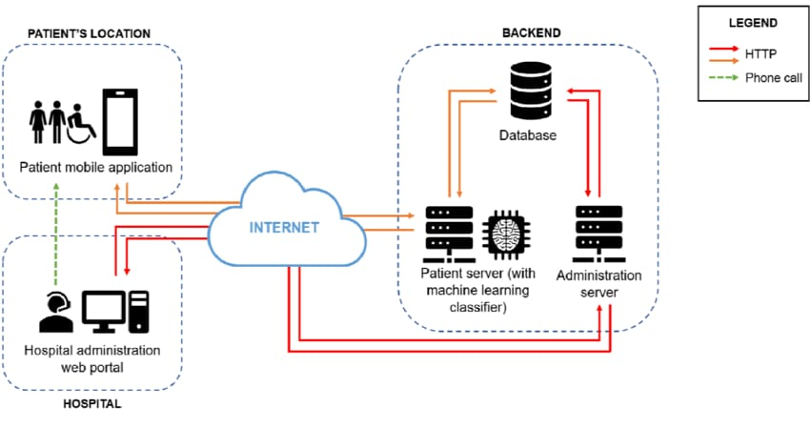

Project Team Members :

Sai Praneetha D
Sai varshitha S
Manogna D
Vedhanath Reddy M
Aveen Kumar S

